ParaBank Bug Report
Tester: Rick
Date: 01-Nov-2025
Environment:
• Browser: Chrome (v130+)
• OS: Windows 10 (64-bit)
• Framework: Selenium + Pytest
• Base URL: https://parabank.parasoft.com/parabank/index.htm

Bug 1 – Site Stores Data for a Temporary Time
Before:
User credentials and form data remain valid only for a short period.
After:
After a few minutes of inactivity, stored data (login session, user info) disappears or becomes invalid.
Description:
Session data or user details appear to expire prematurely, causing test data inconsistency and forcing repeated re-login attempts.
Impact:
• Functional Issue: User experience interrupted.
• Testing Issue: Causes automation flakiness.
• Reliability Issue: Suggests improper session or cookie handling.
Possible Cause:
Server-side session timeout too short or missing persistent storage configuration.
Probable Fix:
• Increase session timeout value in backend configuration.
• Implement persistent session cookies for test environment.
Notes:
Add clear timeout or re-login message to inform users of expired sessions.

Bug 2 – ATM Services Section Has No Styling (Raw XML Displayed)
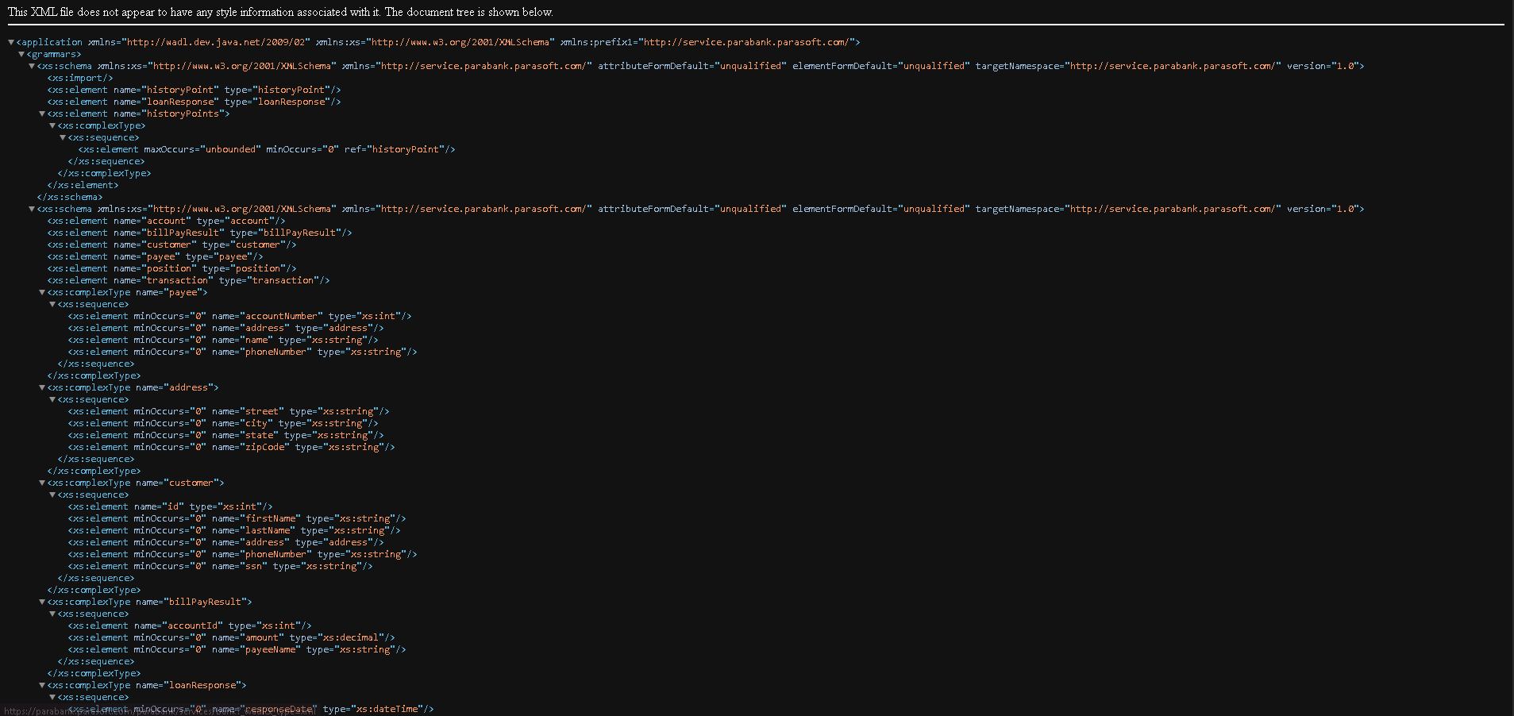
Before:
User navigates to “ATM Services” from sidebar or homepage.
After:
Displayed content shows raw XML or unstyled HTML — no proper UI structure.
Description:
ATM Services page lacks frontend styling or linked CSS resources, showing backend XML output directly.
Impact:
• UI Issue: Poor layout and readability.
• Functional Issue: Possibly missing linked route or template file.
• Reliability Issue: Suggests incomplete frontend rendering setup.
Possible Cause:
Broken HTML link to template or missing CSS/static reference in Flask (or server) configuration.
Probable Fix:
• Verify proper HTML template mapping in backend routes.
• Link stylesheet correctly (<link rel="stylesheet" href="...">).
• Move XML data rendering to backend and render formatted HTML view.
Notes:
Ensure all service sections follow consistent template structure.

Bug 3 – Online Services Page Missing CSS and Layout
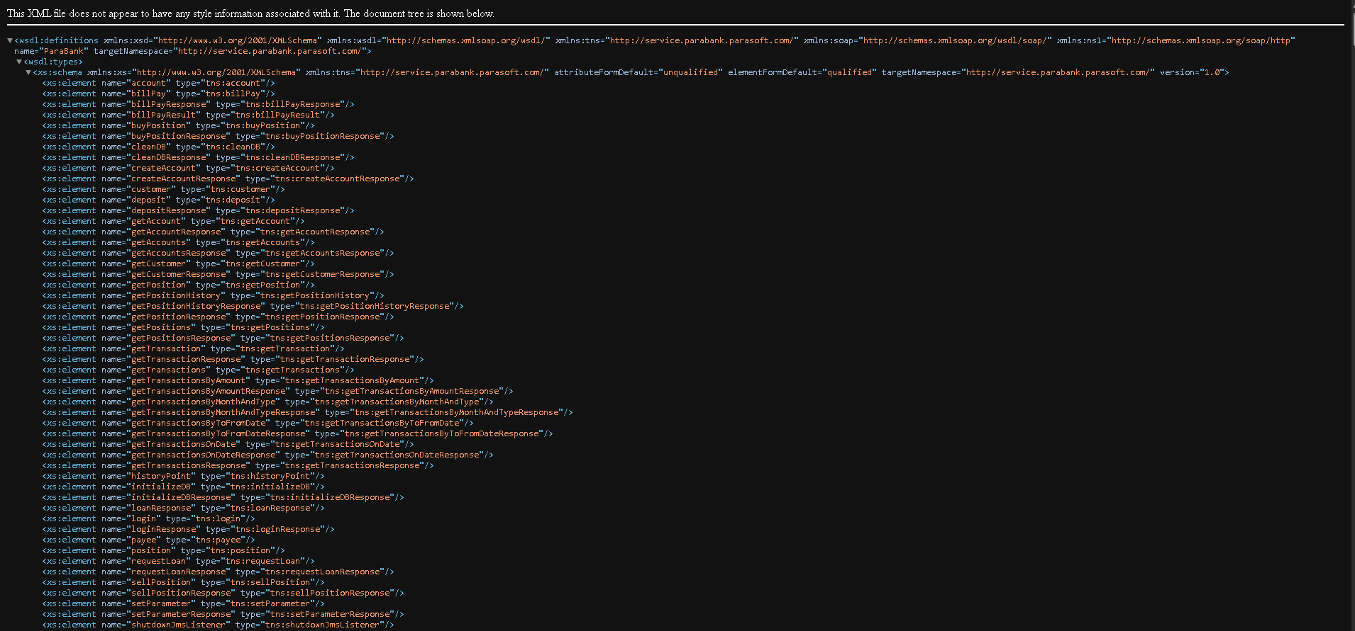
Before:
User navigates to “Online Services” page.
After:
Raw unstyled XML/HTML appears — no proper layout, structure, or color theme.
Description:
Page elements are rendered as plain text, missing both CSS formatting and HTML templates.
Impact:
• UI Issue: Breaks site consistency.
• Functional Issue: Hard to interpret content.
• User Impact: Reduces perceived professionalism and clarity.
Possible Cause:
Missing or incorrectly referenced HTML/CSS templates for the Online Services section.
Probable Fix:
• Add proper onlineServices.html template in correct path.
• Ensure stylesheet path is properly linked in head section.
• Validate resource paths via browser console (Network tab).
Notes:
Verify other service pages (ATM, About, Contact) use consistent design and template hierarchy.

